Q1)

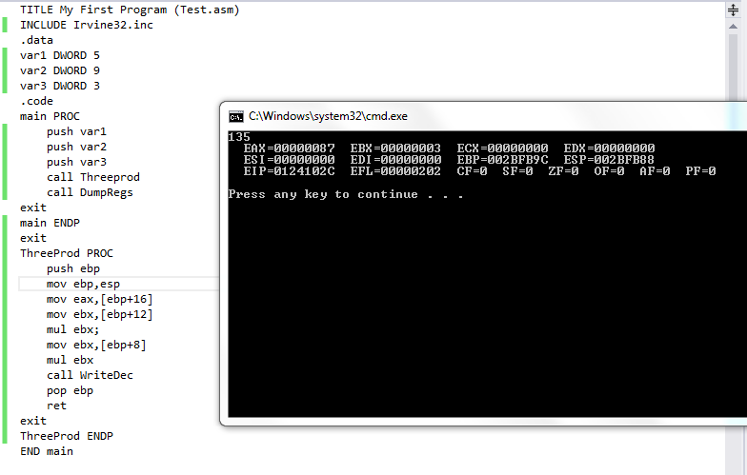

Q2)

TITLE My First Program (Test.asm)

INCLUDE Irvine32.inc

.data

array byte 1,2,3,4,100,6,7,8,9

textMax byte "Minimum value: ", 0

textMin byte "Minimum value: ", 0

.code

main PROC

push offset array

call FindMinMax

call DumpRegs

exit

main ENDP

FindMinMax PROC

Enter 0, 1

mov eax, 0

mov ecx, lengthof array

mov esi, 0

mov al, array[esi]

inc esi

findMax:

mov bl, array[esi]

cmp al, bl

jna saveMax

returnMax:

inc esi

loop findMax

jmp endMax

saveMax:

mov al, bl ;greater is going

jmp returnMax

endMax:

mov edx, offset textMin

call writeString

call writeInt

call crlf

mov eax, 0

mov ecx, lengthof array

mov esi, 0

mov al, array[esi]

inc esi

findMin:

mov bl, array[esi]

cmp al, bl

ja saveMin

returnMin:

inc esi

loop findMin

jmp endMin

saveMin:

mov al, bl ;lower is preserved

jmp returnMax

endMin:

mov edx, offset textMax

call writeString

call writeInt

call crlf

leave

ret

FindMinMax ENDP

END main

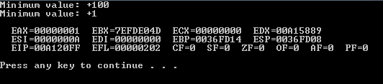

Q3)

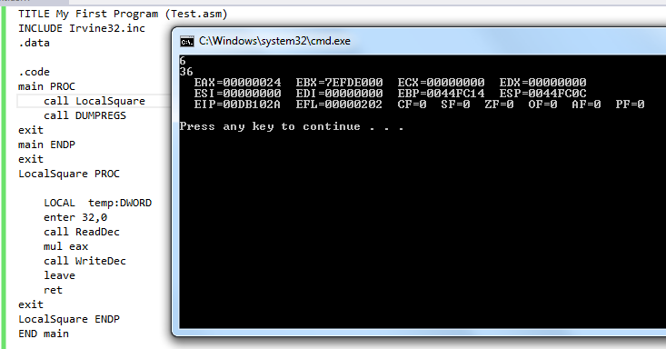

Q4)

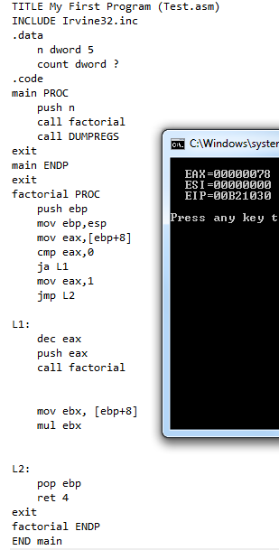

Q5)

